Mineral Resources in Western Australia

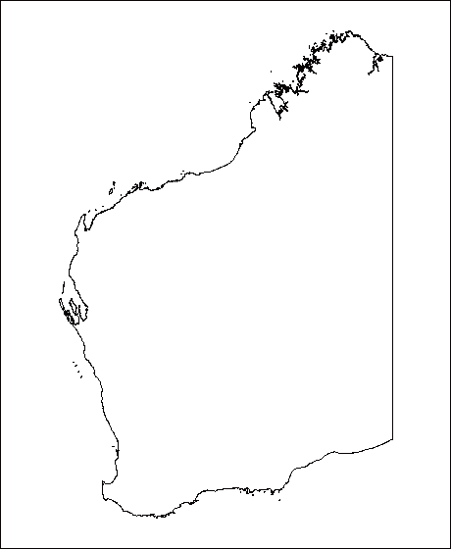

*Key:*

|  |  |  |  |
| --- | --- | --- | --- |
| **Symbol** | **Mineral** | **Symbol** | **Mineral** |
|  | Aluminium |  | Lead |
|  | Copper |  | Nickel |
|  | Diamond |  | Silver |
|  | Gold |  | Titanium |
|  | Iron |  | Zinc |